Stewards MKMCF Ma Ko Pan Memorial College

S.2 ICT Micro:bit Project

**Bomberman Game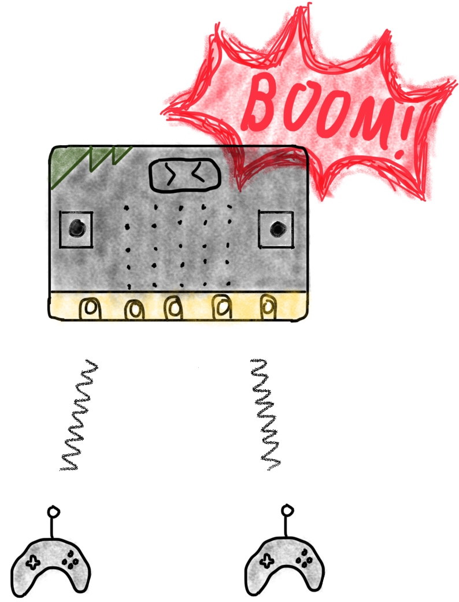Content**

Self & Game introduction …............................. P.3

Program introduction.................................. P.4-14

Resources ….................................................... P.15

Ending …......................................................... P.16

Thanks list …................................................... P.17

P.2

**Self-introduction** 

Hi! I am Paco from class 2D, I have made a microbit program for my ICT project “Bomberman Game”. Now I’m going to introduce the program.

**Game introduction** 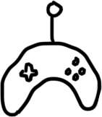

By the way before that, you should know what is bomberman game. That’s a little game we can play with our friends. First, there will be a bomb with a random number(10-25). Then a player will be random to play first. The players can enter number 1 to 3. Then is the next player’s turn. When the sum of the number that’s the players entered is higher or equal to the bomb, the game will end. The player that’s entered the last number will be the loser. It is an interesting game! Now let’s have a look of the program!

P.3

**Program** **introduction** 

**Main** **concept** 

When I saw that we need to use three microbits to act a console and two players and use two programs to play the game, I think it's not very made sense and convenient because the players rely on the console to process their uploaded data. So I delete the console in my code. Let the players exchange their data each other and process together, just like formed a virtual console. Images below.

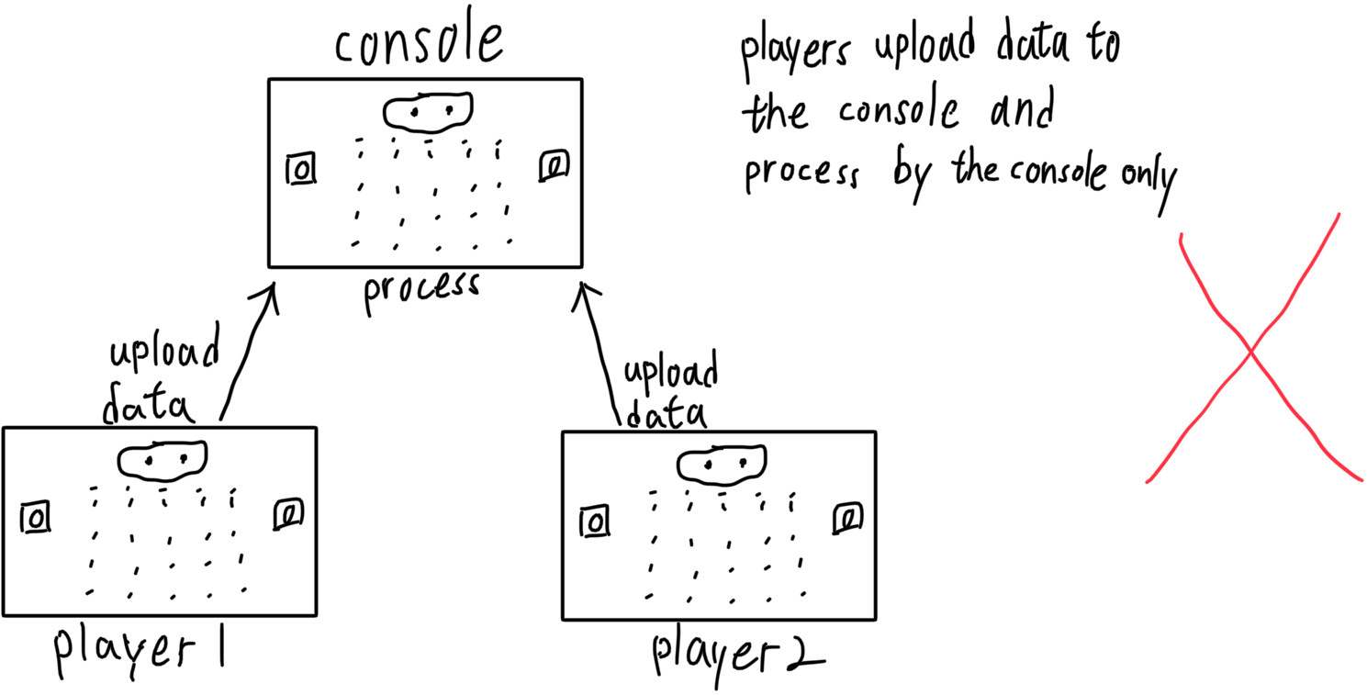

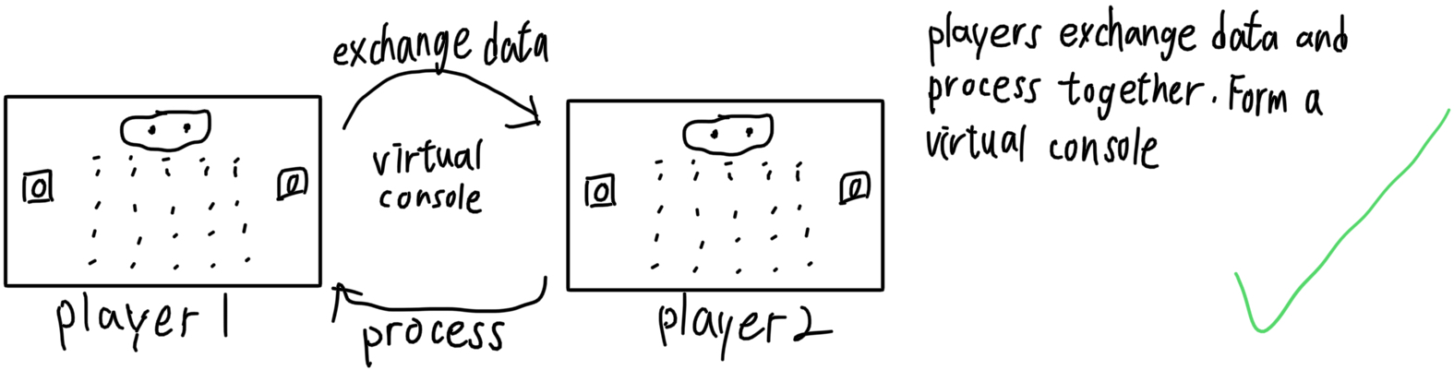

P.4

**Security** 

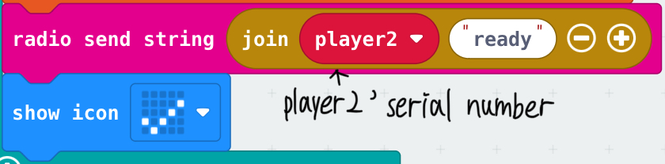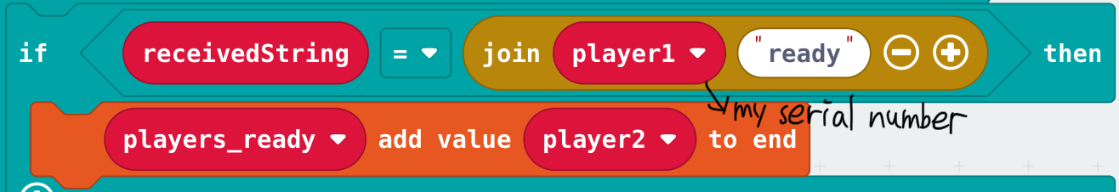

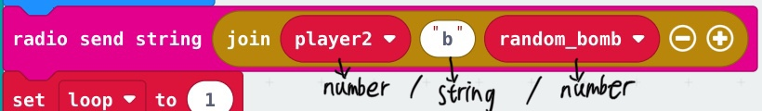

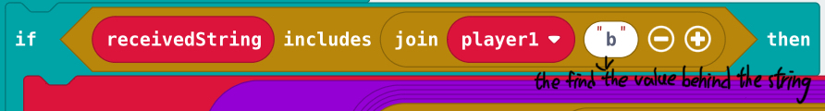

When the players are exchanging data, the data will mix with the other pair of players’ so I encrypt the data before send out. The principle is adding the paired players’ serial number in front of the string or number that you want to send. When that player received the whole sentence, it will check is the received serial number same to its device serial number first, if they are same, it will start reading the string or number. It is also work to encrypting variables.

P.5

**Pair** 

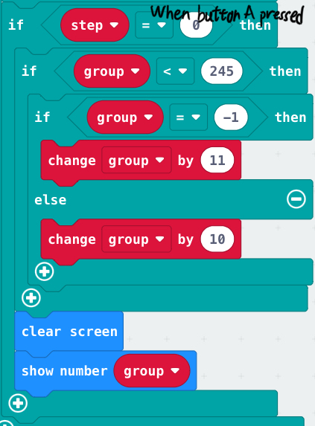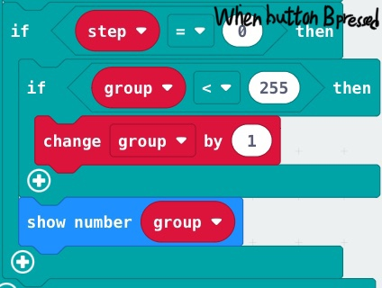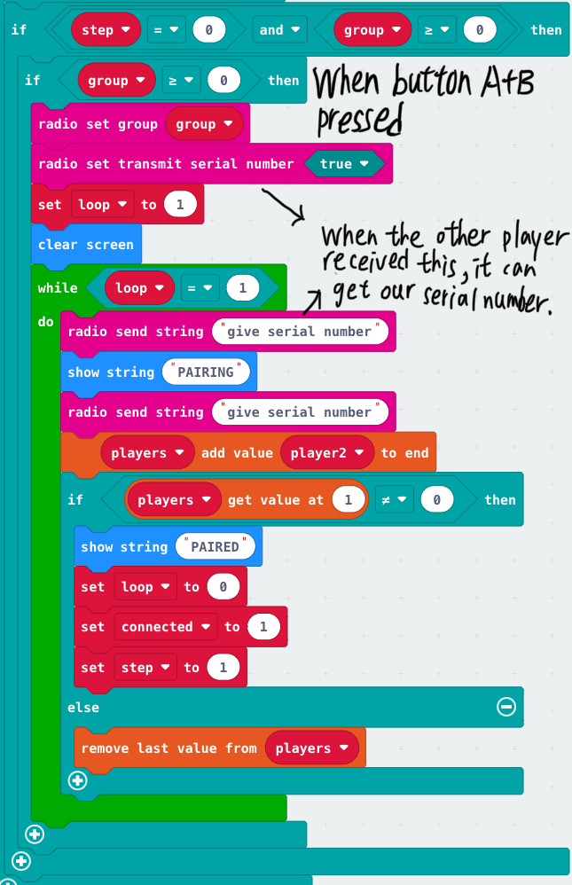 First, for having a higher freedom, I've made a pair system. We need to enter the radio group number(0-255) by pressing button A/B. The group number will be change by 10 when button A is pressed. When button B pressed, the radio group number will be change by 1. Then, press button A+B to start pairing.(*The entered radio group number must be same with your friend’s entered radio group number. If not, you cannot pair with your friend.)

P.6

**Ready** 

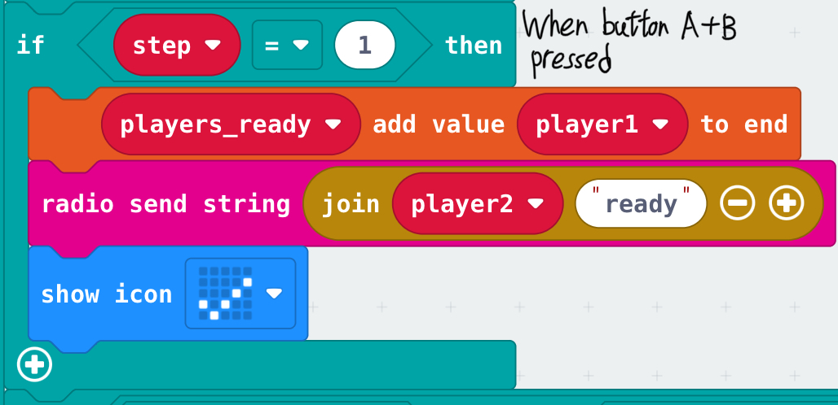 After paired, we need to press button A+B to get ready and wait for the game start. Make sure that the game start in the same time.

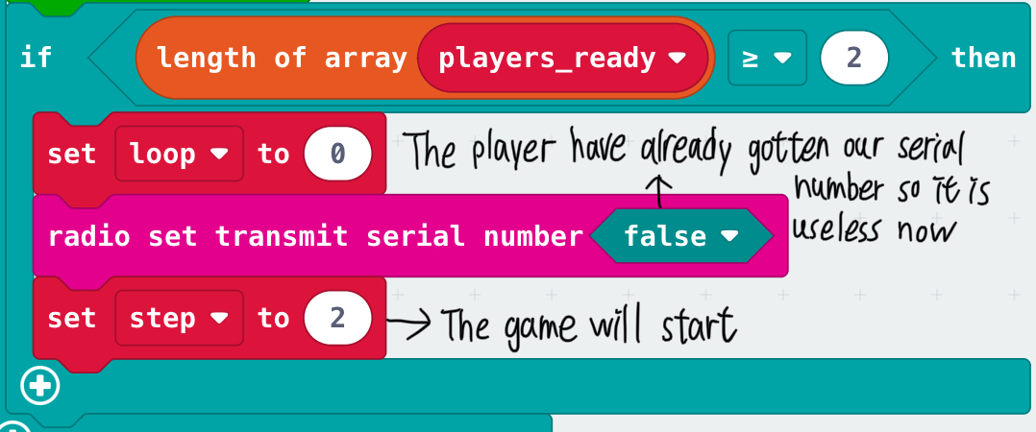 When the players both got ready, the serial number will close so it cannot be gotten anymore. Then the game will start at the same time.

P.7

**Random** 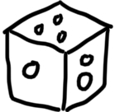

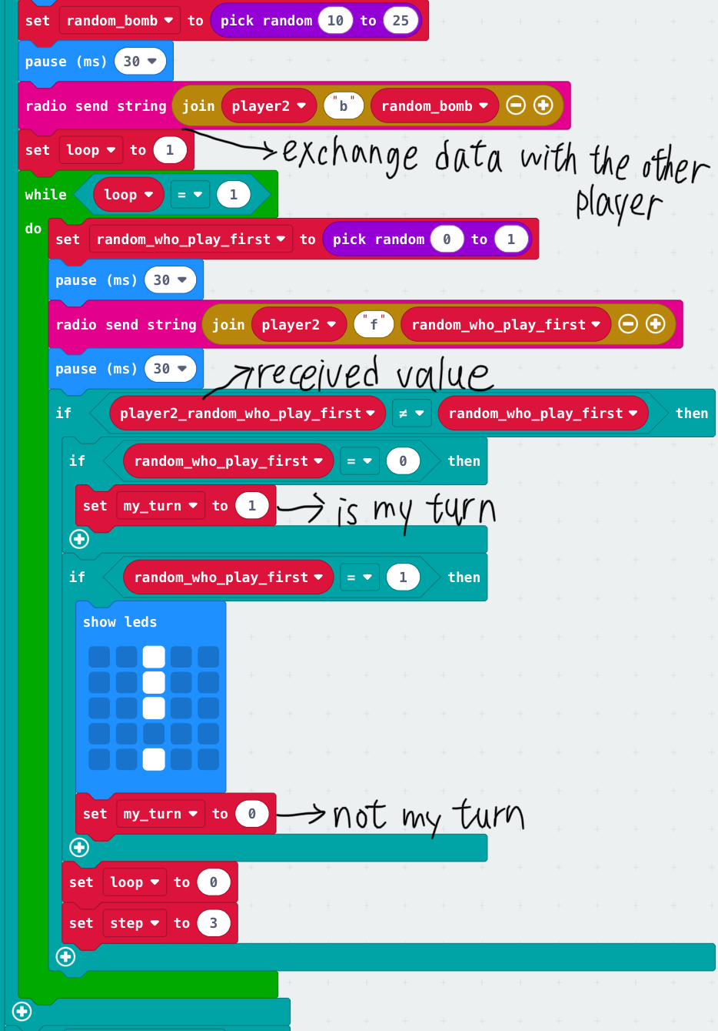 When the game started, each player will random a value of bomb and random a player to play first. Then it will send the numbers. After random a player to play first, that player will start first.

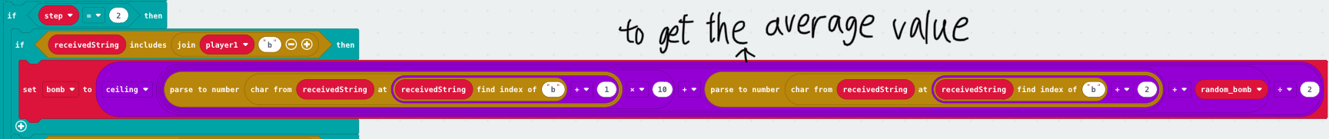 Because of the random number of the players are different, so they will share their random number each other and get the average value. Make sure that their value of bomb are same. It is similar to human society, when people have different options, they will find the same point too.

P.8

**Play** 

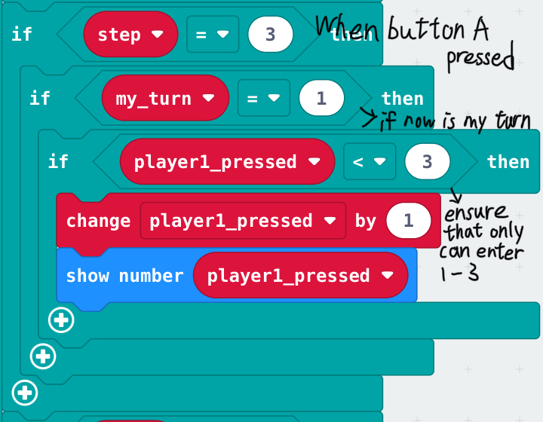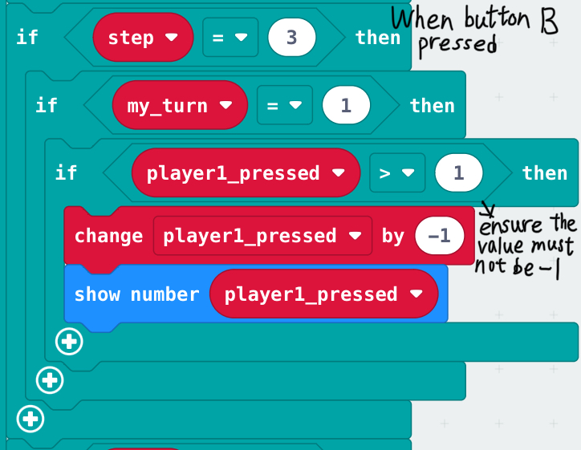

When it is your turn, you need to press button to increase 1 or press button B to decrease 1. (The range is 1-3)

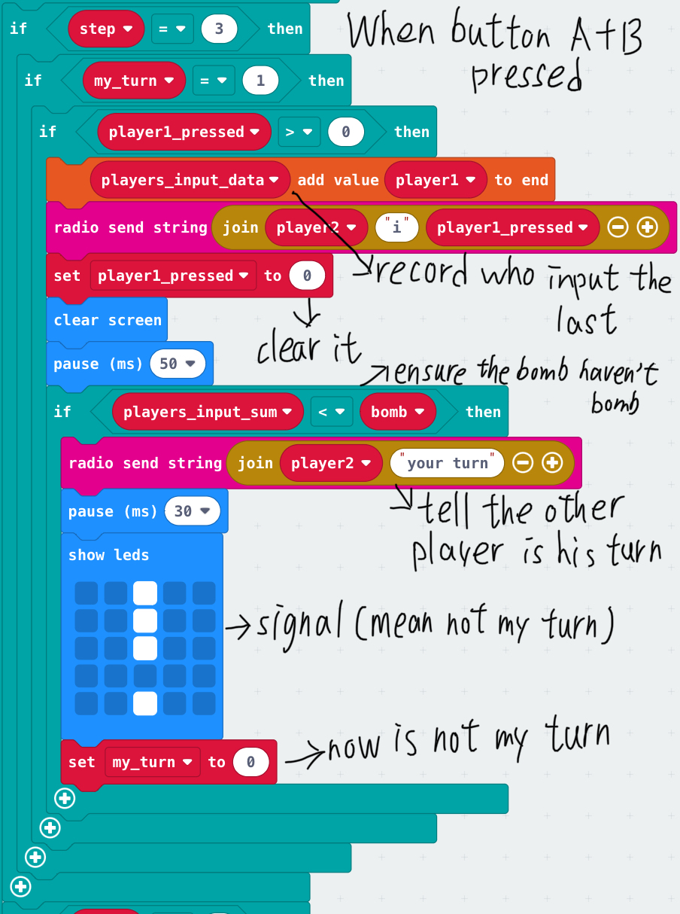

After that, press button A+B to send the value. Then it is the next player's turn.

P.9

**Game over** 

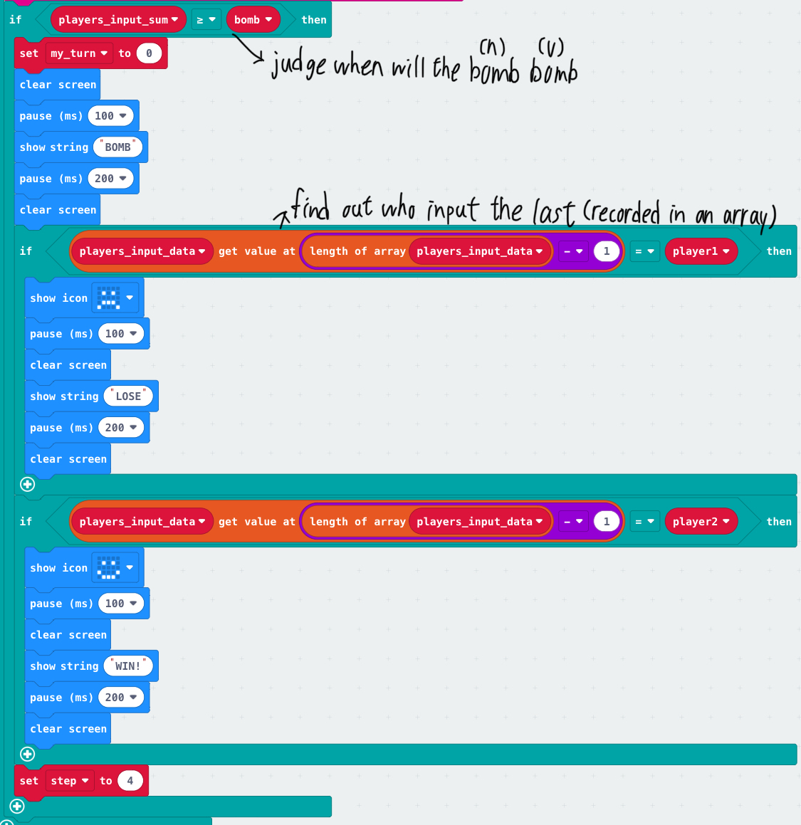

When the sum of the players’ total pressed is higher or equal to the bomb, the game will be over and the players will find out who is the last player to input the number. If the last player is itself, it is the loser. Opposite, if the last player is not itself, it is the winner.

P.10

**Rematch** 

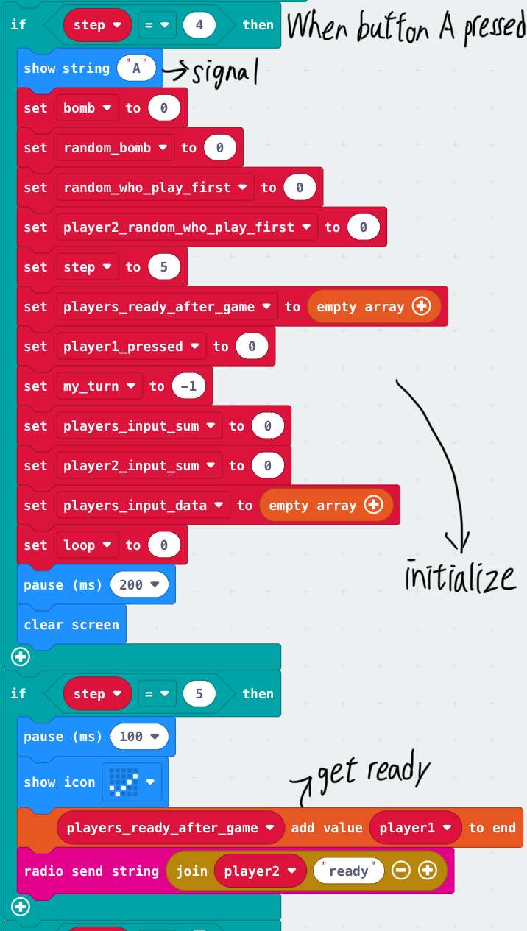 After the match, if you want to have a match again with the same paired player, you no need to pair again, just press button A to get ready for the new match start. When the players both got ready, the game will start.(*There is a bug, read P.14)

Also, if you don't want, just press button B to reset the game and you can pair with other players.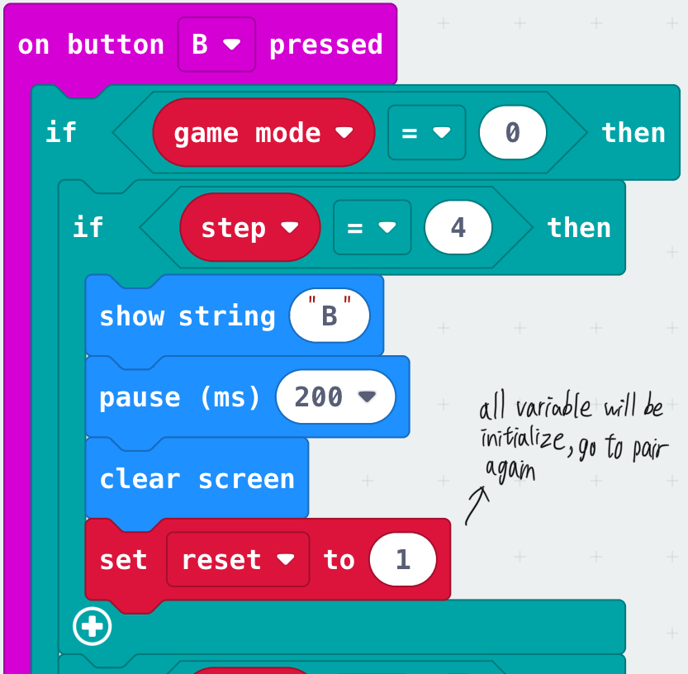

P.11

**Disconnect** 

When the distance between the players is too far, the connection of the players may be unstable. For solving it, I have limited the signal strength range. The normal range is -42 to -128, so I limited it to -42 to -110 because I thought it is a suitable and acceptable range. When the signal strength exceeded the range, the game will stop immediately and disconnect with the other player. Then the game will reset so you need to pair again, remember to make sure that the signal strength is in the range otherwise it cannot pair successfully.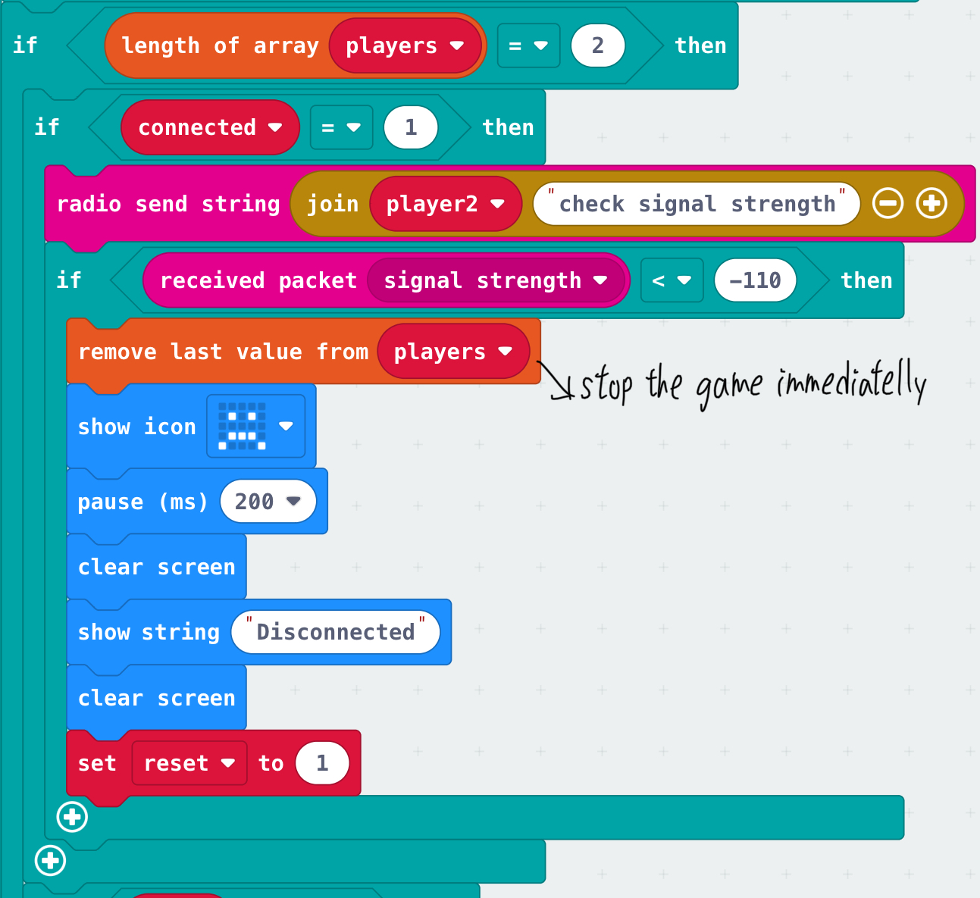

P.12

**Hidden game** 

Now the microbit have a multiplayer game, but when there is only one player, the game cannot work, so I added stand-alone game to the program, “catch the coin”. After you pressed button A+B to start this game, the top of the screen will drop a coin that’s drop from a random place. Then you need to control the sprite by button A/B to catch the dropping coin at the bottom. If you catch the coin successfully, the score will change by 1 and the other one coin will be dropped again. If you couldn’t catch the coin, the game will end and show the score.

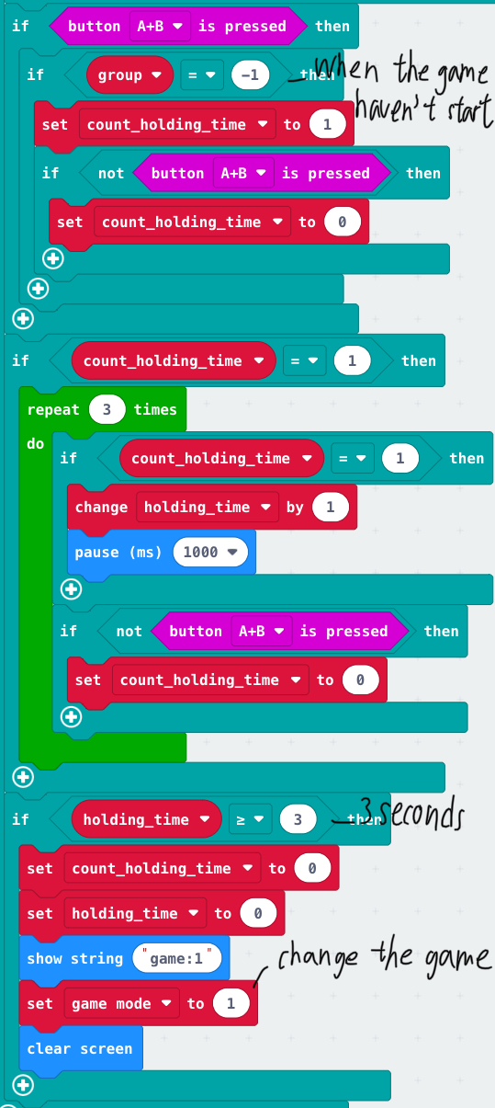 Then how to change the game to the stand-alone game form the multiplayer game? Before you enter the radio group number, hold button A+B three seconds to change the game. You can change the game back to the multiplayer game by the same way.

P.13

**Bugs** 

In programming, almost each program have bugs, in this program, there are many bugs also. So how did I fix these bug? Just try! I thought a lot of different solutions to solve the bugs. Although the solutions look so strange and not make sence, they worked! You can see many strange places in my code, All of them are for fixing bugs. Example:

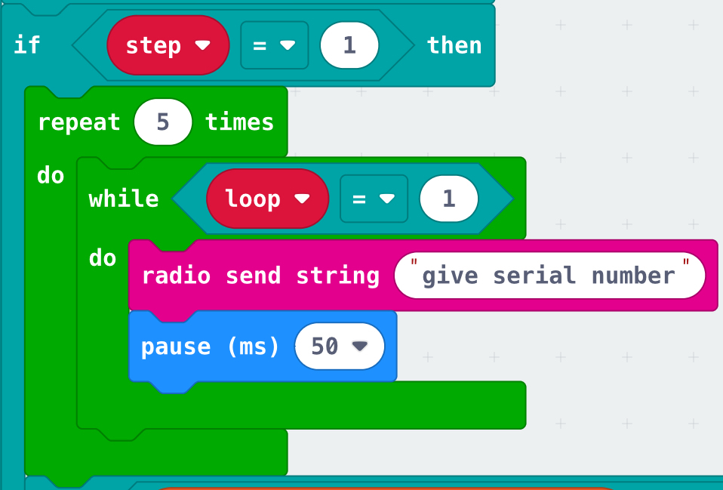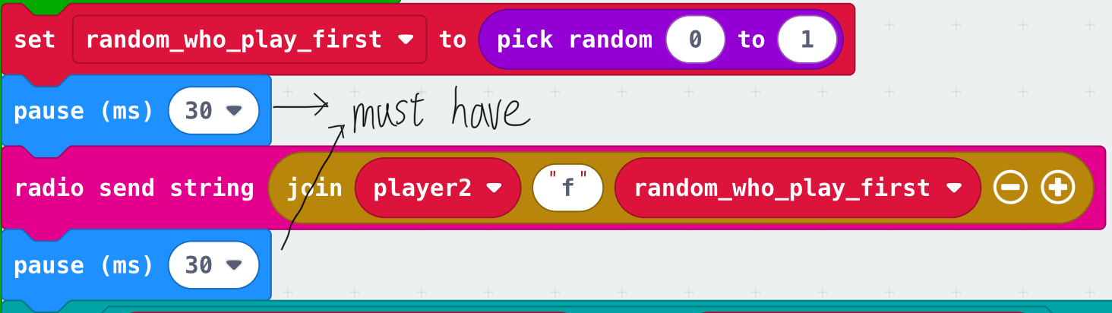 But there is one bug haven’t fixed yet. It is in the rematch part. If the players want to start a new match, the players must press button A at the same time. Otherwise one player will start the game, one player won’t.

P.14

**Resources** 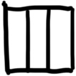

**Running video** 

[**https://youtu.be/7y3eGbMaajA**](https://youtu.be/7y3eGbMaajA)

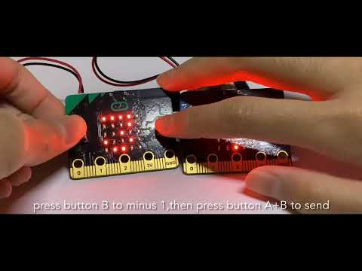

**Program file & Others** 

[**https://github.com/kakaho0902/Bomberman-Game/tree/main**](https://github.com/kakaho0902/Bomberman-Game/tree/main)

P.15

**Ending** 

Although I started work on this project since 28th of November, I handed in this project late. I’m sorry about that. This project is quite challenging, I have learnt a lot. That’s the end, thank you for your patience!

*A thank list in the next page.

P.16

**Thank list** 

• **Mr. Fan**

(He taught me new things example radio, array, serial number, signal strength.)

• **Wong Yin Yan (2D)**

• **Wong Chun Hei (2C)**

• **Ho Hing Kiu (2D)**

• **Lee Man Ho (2C)**

• **Lam Ka Pui (2D)**

(They borrowed their microbit to me for testing the program.)

• **Ho Hing Kiu (2D)**

• **Lam Ka Pui (2D)**

(They helped me to test my program.)

• **Ms. Chu**

(She praised me, made me became more confident.)

**Thank for all of you!**

P.17

**-The End-**